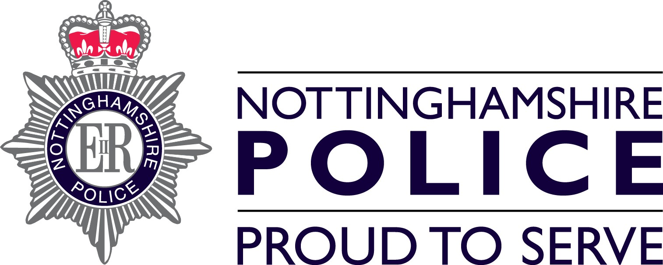 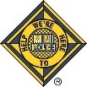

Nottinghamshire Mini Police

The Nottinghamshire Mini Police is an engagement scheme designed to improve citizenship within our communities and give young children the opportunity to learn about their safety, their role within their community and how the police work within the community to keep us safe.

The scheme is aimed at children in year five within their school (age 9-11yrs) and focuses on the contribution young people can make into our communities to make it a better place to be. The scheme will improve the relationship between the police and the communities they serve and gives young people a voice to say what matters to them and to influence people around them in a positive way.

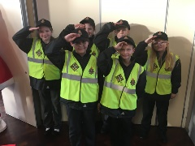 [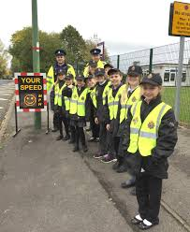](https://www.google.co.uk/imgres?imgurl=http://www.newtonnews.co.uk/wp-content/uploads/2016/10/mini-police-1.jpg&imgrefurl=http://www.newtonnews.co.uk/mini-police-on-speedwatch/&docid=t7J-ZXfrAp-9oM&tbnid=qa6__g2gJFk-qM:&vet=1&w=2400&h=2928&bih=651&biw=1366&q=mini%20police&ved=0ahUKEwjht_vP1v3RAhXsJcAKHfi8DZYQMwiHAShhMGE&iact=mrc&uact=8) [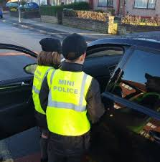](https://www.google.co.uk/imgres?imgurl=http://www.southportreporter.com/788/MINI-POLICE-JOIN-NATIONAL-CAMPAIGN-%20(3).jpg&imgrefurl=http://www.southportreporter.com/788/788-15.shtml&docid=arwljgQK6SqjEM&tbnid=dDT4KrZqAbA6xM:&vet=1&w=344&h=350&bih=651&biw=1366&q=mini%20police&ved=0ahUKEwiMhILX1_3RAhVdOMAKHYXFBHs4ZBAzCFYoVDBU&iact=mrc&uact=8)

**How does the scheme work?**

The scheme runs alongside an academic year – it begins each September and the children in year six of school leave the scheme when they move into the next school year at the end of the summer.

Children in year five will be visited by the Mini Police team who will explain what we do, what the children will be asked to do and to show the work we have done before. Class teachers will then decide on a group of twenty children who would like to join us – this is not based on academic ability but is based on children who will enthusiastically join in with all of our activities. In order to take part, both parents and class teachers must sign a consent form and be fully supportive.

**I am part of the Mini Police – what will I be doing?**

Once you have joined us, we will be visiting you in school at least once per term, during school time. You will take part in a session where we work on topics such as water safety, healthy relationships, online safety and many other topics. Sessions will be interactive and tailored to suit each separate Mini Police group and the community they live in.

After this, it will be your job to then tell the rest of the school all about what you have learned – whether this is on your newsletter, noticeboard, website or even in assembly – you are the Mini Police for your school and very important in helping Nottinghamshire Police to spread important messages about keeping safe.

Your Mini Police group will then come out into the community with the Mini Police team. What you do will depend on what is happening in your area but examples of community work include helping out at the Robin Hood Marathon, carrying out surveys with residents to help improve the area, helping at Christmas tree lighting events etc. After this we will arrange an exciting visit to some of the different departments within the police, so you can learn more about what police officers do. This might be a trip to see the police dogs, visiting the control room to listen to 999 calls and watch how we manage our officers out and about and even a visit to the helicopter.

[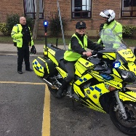](https://www.google.co.uk/url?sa=i&rct=j&q=&esrc=s&source=images&cd=&cad=rja&uact=8&ved=0ahUKEwillLjg1v3RAhWIMhoKHbzKA8AQjRwIBw&url=http://www.greenlandprimary.durham.sch.uk/pupils/mini-police/&psig=AFQjCNEhw2cOS3v4jxiJrUgGzoR-bgd-ug&ust=1486546295173557) [](https://www.google.co.uk/url?sa=i&rct=j&q=&esrc=s&source=images&cd=&ved=0ahUKEwie4Yz61v3RAhWG2hoKHf8DDnAQjRwIBw&url=https://www.merseyside.police.uk/news/latest-news/2016/09/mini-police/&psig=AFQjCNEhw2cOS3v4jxiJrUgGzoR-bgd-ug&ust=1486546295173557&cad=rjt) [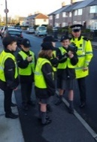](https://www.google.co.uk/url?sa=i&rct=j&q=&esrc=s&source=images&cd=&cad=rja&uact=8&ved=0ahUKEwi5q7yS1_3RAhWJtxoKHXuMD7sQjRwIBw&url=https://merseyside.police.uk/news/latest-news/2016/11/mini-police-join-national-campaign-to-warn-speeding-drivers/&psig=AFQjCNEhw2cOS3v4jxiJrUgGzoR-bgd-ug&ust=1486546295173557)

**How will people know I am part of the Mini Police?**

You will be given a uniform to wear as part of the Mini Police. Your class teacher will keep it at school for you and every time you do any work with the Mini Police team you will wear it. Your uniform consists of a cap, waterproof jacket and hi-viz vest each with the logo on. This means you can easily be seen and be safe when out in the community with us. Every time you work with us we will carefully assess any risks there might be and your parent, teacher or guardian will come with you when we go out of the classroom.

**Can I join even if my school doesn’t have the Mini Police?**

Unfortunately not – we work with schools and have a Mini Police group in a school rather than a group made up from children in different schools. This means that we can really focus on what’s important to the community around the school and also that we can work together as one team.

*We are looking forward to you being part of the Nottinghamshire Mini Police team!*